Project Design Phase
Problem – Solution Fit Template

Date | 30 September 2026
Team ID | SN-TRANSFORM-01
Project Name | Import Data using Transform Maps (Spreadsheet)
Maximum Marks | 2 Marks

Problem – Solution Fit:
The project fits the needs of ServiceNow administrators and HR data owners who receive employee spreadsheets and must import accurate records quickly, repeatedly and without duplicates.
Purpose:
- Fit the workflow to the administrator’s real job: stage, map, transform, validate and report employee data.
- Use the existing spreadsheet and ServiceNow UI behavior instead of asking users to adopt a separate data-entry channel.
- Build trust through Employee ID coalescing, visible transform history and clear inserted / updated / ignored outcomes.
- Reduce recurring import friction by standardizing the target table, field mapping, reports and dashboard.
- Improve the current situation for HR and data owners by making employee data quality observable and repeatable.

Problem – Solution Fit Canvas:
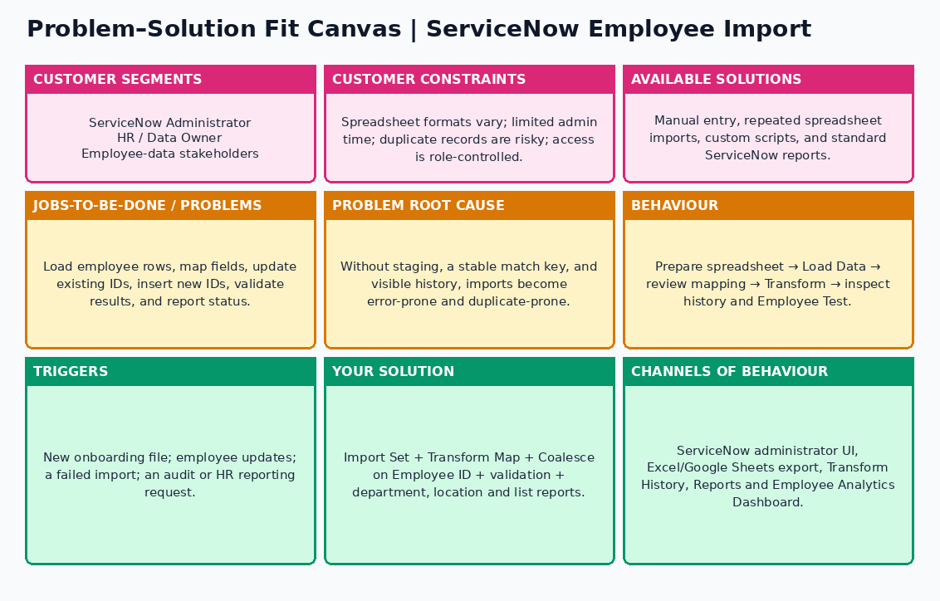
References:
- Project brief: Import Data using Transform Maps (Spreadsheet)
- Phase-II Solution Requirements and Solution Architecture artifacts

